**DOT-11212: Call Center Order Creation Test Results**

Step1:- Login into MAO  
Test Step: Passed  
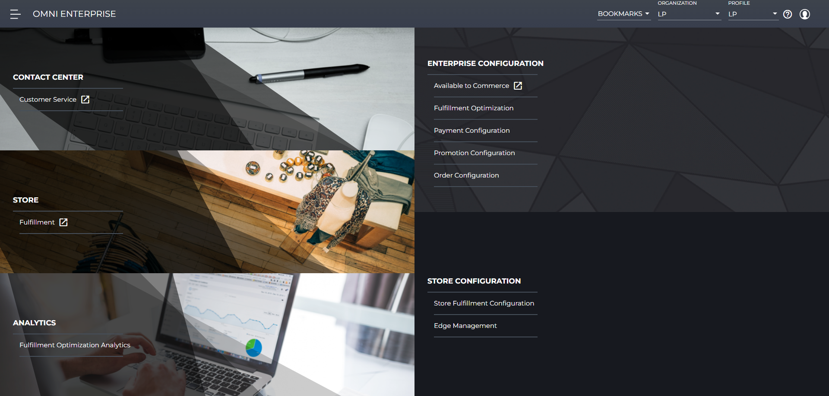

Step2:- Change Organization  
Test Step: Passed  
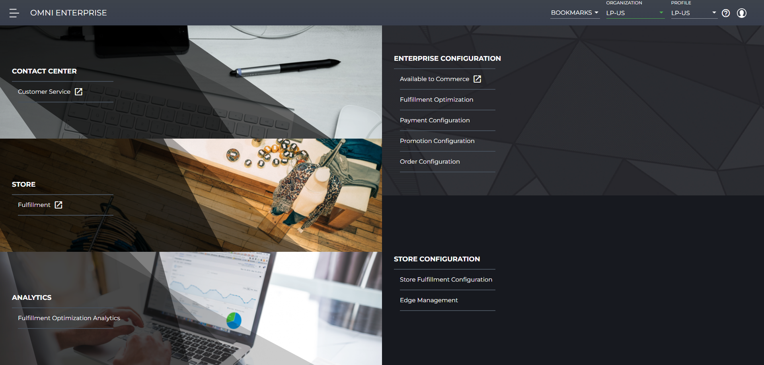

Step3:- Navigate to CSR UI  
Test Step: Passed  
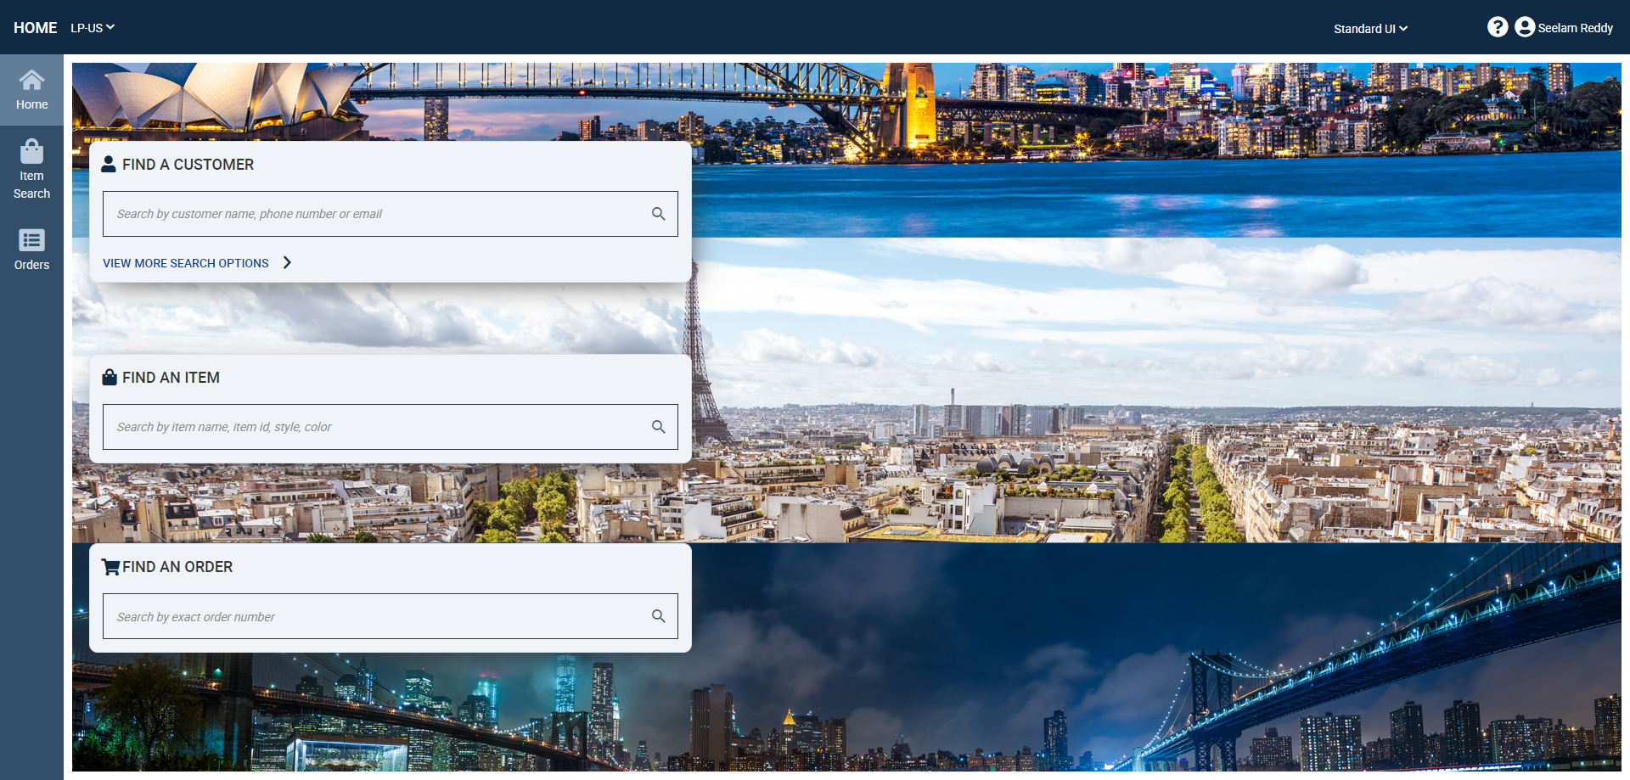

Step4:- SKU Search  
Test Step: Passed  
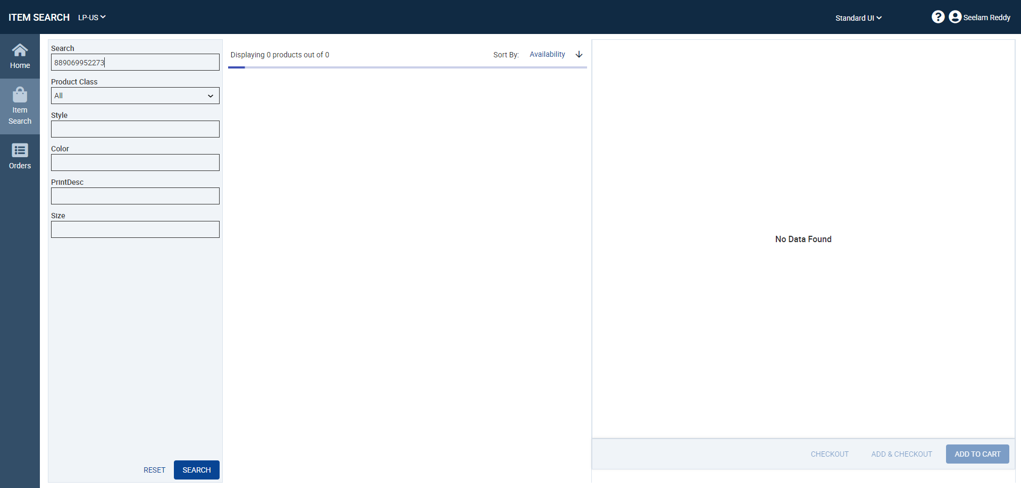

Step5:- Customer Selection  
Test Step: Passed  
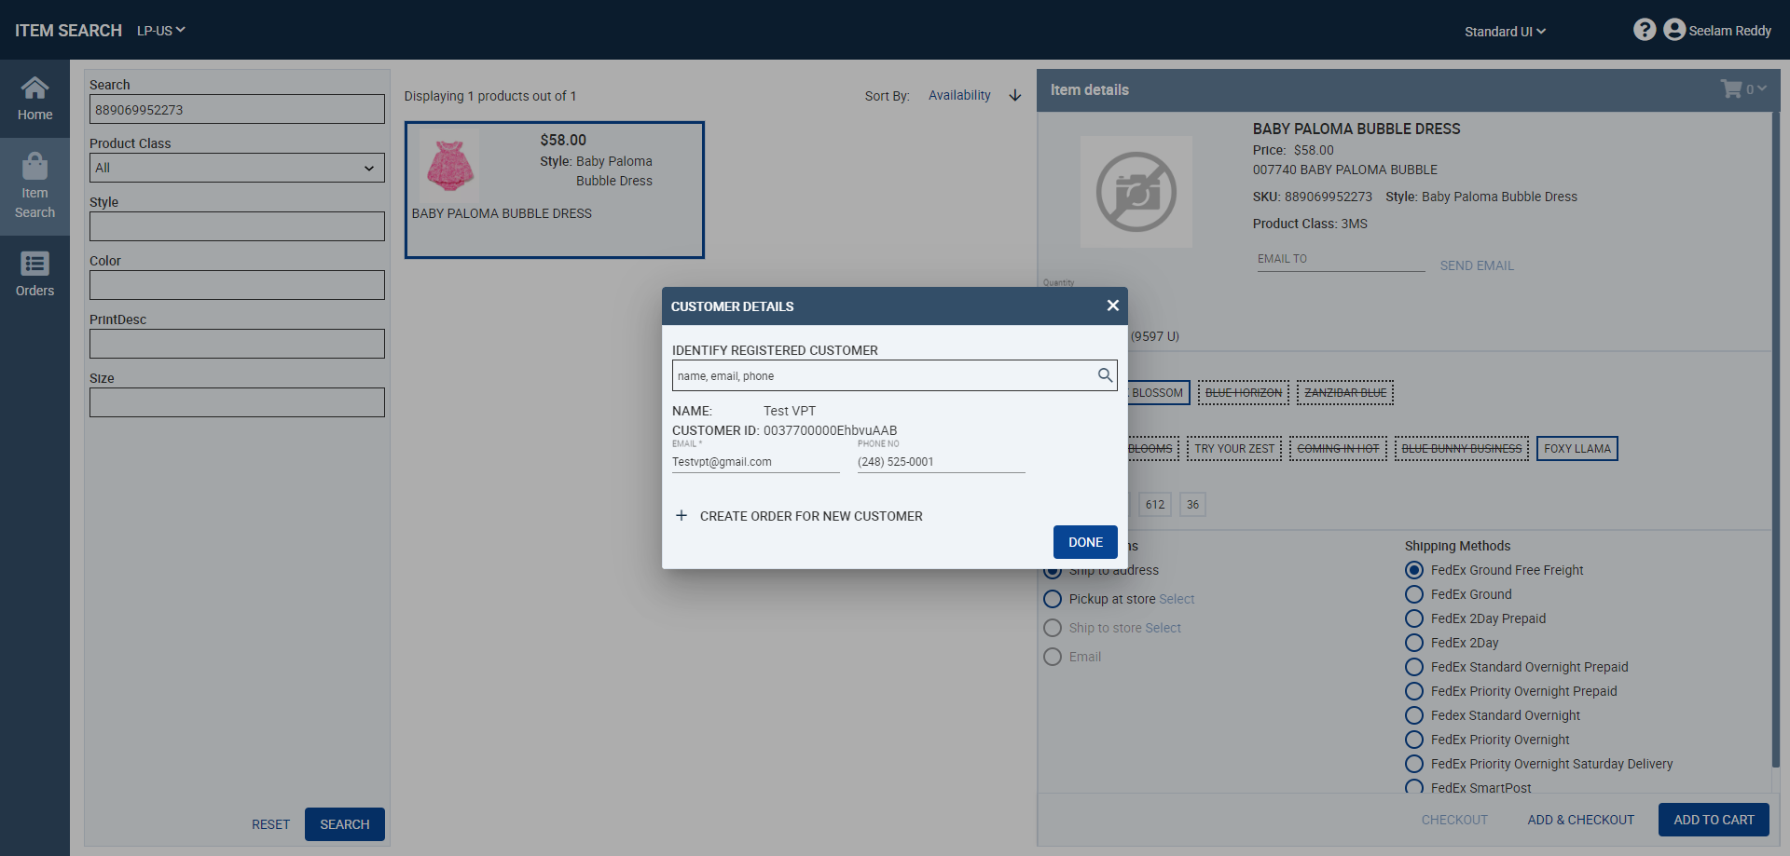

Step6:- Proceed to Payment  
Test Step: Passed  
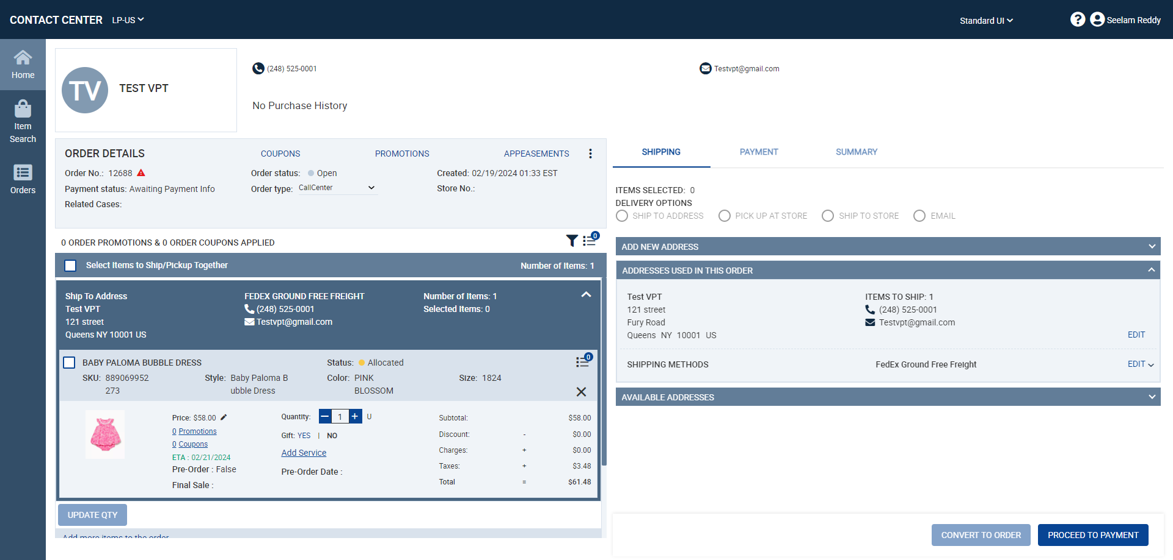

Step7:- Proceed to Summary after Credit Card details submission  
Test Step: Passed  
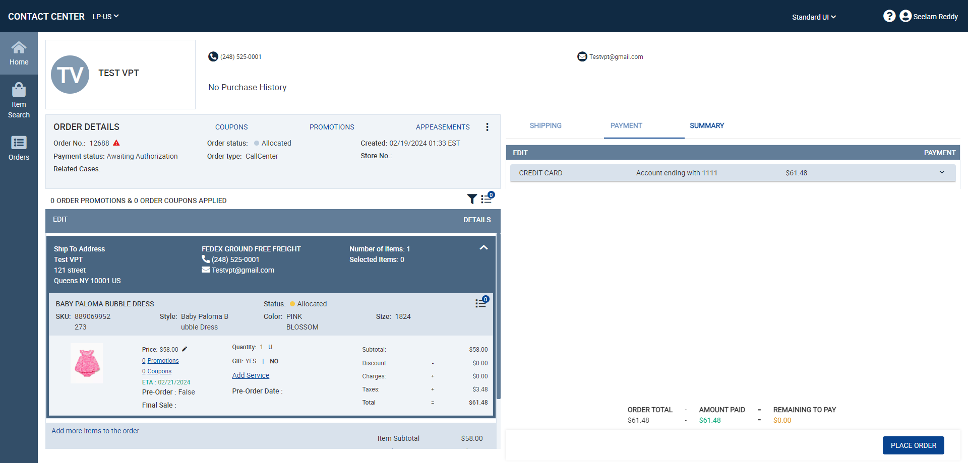

Step8:- Place Order  
Test Step: Passed  
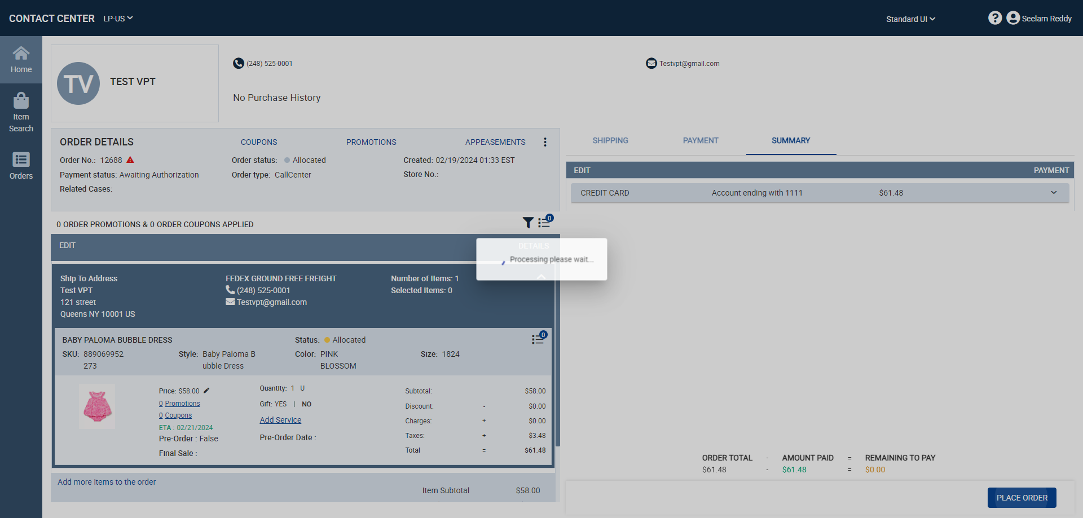

Step9:- Order Successfully placed: 12688  
Test Step: Passed